be


CASSOWARY COAST REGIONAL COUNCIL

TENDER SALE
King Ranch Theatre Building & Land
Ranch Road, Munro Plains, Qld
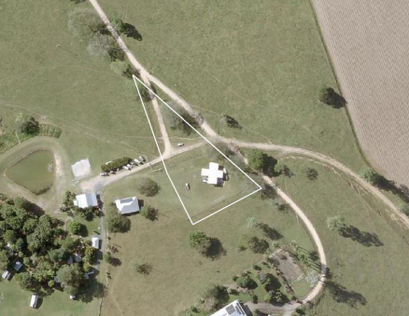

Table of Contents

1. Introduction 2
2. Property details 2
3. Sale by Tender 3
4. Photographs 6
5. Title search 10
6. Improvements 10
7. Rates and Charges 11
8. Contact 12
9. Authorisation 12
10. Site inspections 12

ANNEXURE A ……………………………………………..REIQ CONTRACT
ANNEXURE B ……………………………………BUILDING FLOOR PLANS
ANNEXURE C…………………………..BUILDING INSPECTION REPORT
ANNEXURE D…………………………………………..REGISTERED PLAN

Introduction

Cassowary Coast Regional Council is offering for sale Lot 1, Ranch Road, Munro Plains Qld 4854 (Lot 1 on Survey Plan No. 152304, Title No. 50440218).
The property is offered on an ‘as is’ basis and interested parties are responsible for undertaking their own research to ensure the property is adequate for their requirements.
This tender contains the following information for consideration:

- Property details
- REIQ – Contract for Sale – Annexure A
- Building plans – Annexure B
- Property building inspection report – Annexure C
- Registered Plan – Annexure D

Property details

Property description: Lot 1 on Survey Plan 152304
Tenure: Freehold
Registered owner: Cassowary Coast Regional Council (being the predecessor in Title to the Council of the Shire of Cardwell)
Local Authority: Cassowary Coast Regional Council
Land size: 5,071m2
Zoning: “Rural” under the Cassowary Coast Regional Council Planning Scheme 2015
Location: Bilyana / Murray Upper is a rural area located approximately 25 kilometres by road south of Tully and 160 kilometres south of Cairns. The property is accessible via registered easements off Ranch Road, Munro Plains.
Encumbrances: Registered Access Easements Nos. 702614614, 702999954, 702999975 and 706556121

Sale by Tender

Tender:
The property is offered for sale by tender

Tender closing date:
Friday, 7 March 2025

Expected minimum price offer:
$250,000 + GST
Note: The property is not sold as a residence and accordingly the sale will be subject to GST

Tender Evaluation Date:
Tenders remain open for acceptance for a period of 30 days from the Tender Closing Date.
The successful tenderer will be required to execute and submit with their tender an REIQ Commercial Land and Building Contract in the form attached to this document.

Tender Evaluation / Criteria:
Criteria | Weight
Price | 80%
Value to local community including social, economic and environmental outcomes | 20%

Submissions are to be emailed to: purchasing@ccrc.qld.gov.au

Tender Form
Contract: King Ranch Theatre and Buildings
Ranch Road, Munro Plains, Qld
[TENDERER TO INSERT CORRECT LEGAL NAME OF RESPONDENT] (Respondent):
- offers to purchase the property described in this Request for Tender document

- for the sum of:
Price in figures (excluding GST): |  | $[RESPONDENT TO COMPLETE]
GST in figures: |  | $[RESPONDENT TO COMPLETE]
Price in figures (including GST): |  | $[RESPONDENT TO COMPLETE]
('the Price');

- acknowledges that it has read and understood the Request for Tender and in particular all of its obligations under, warranties given or to be given in, and representations made or to be made in, the Request for Tender or any part of it;
- warrants and represents that all information provided by the Respondent in the Response is true and correct; and
- acknowledges that this Response remains valid and open for acceptance until the end of the Response Validity Period.

Signed for and on behalf of the Respondent by the person identified below, who warrants by signing that they are duly authorised to sign for and on behalf of the Respondent:
Name: | [RESPONDENT TO INSERT NAME OF SIGNATORY]
Position: | [RESPONDENT TO INSERT POSITION OF SIGNATORY]
Signature: | [RESPONDENT TO SIGN]
Date: | [RESPONDENT TO INSERT DATE]
Note: The Tender Form is to be signed by a person or persons having full authority to bind the Respondent for the purposes of the Response and evidence of such authority must be provided on request.
Collection, use and disclosure of information
The Principal collects personal information and non-personal information in the Response so that it can properly conduct the procurement process and otherwise carry out its functions as a local government authority. The Principal is authorised to collect this information under the Local Government Act 2009 (Qld) and the Local Government Regulation 2012 (Qld). The information in the Respondent’s Response will be accessible by employees of the Principal and third-party personnel engaged to assist the Principal in conducting the procurement process or otherwise carrying out the functions of the Principal. Information in the Response may also be disclosed in accordance with the Procurement Process Conditions and as required by law, including the Local Government Regulation 2012 (Qld) and the Right to Information Act 2009 (Qld).

Schedule A – Respondent’s Details
Schedule A – Respondent’s Details
Details of Respondent | Name of Respondent:
 | Trading name: Leave blank if the Respondent is not a business
 | ABN: Leave blank if the Respondent is not a business
 | ACN:Leave blank if the Respondent is not a company
Details of Respondent during the Tender Process. | Name of Respondent:
 | Mobile Number:
 | Email Address:
 | Postal Address:
If applicable details of Respondent‘s representative during the Tender Process. | Name of Representative:
 | Mobile Number:
 | Email Address:
 | Postal Address:

Schedule B - Respondent to insert any relevant details that satisfy the evaluation criteria
Schedule B – Value to local community including social, economic and environmental outcomes

Schedule C – REIQ Contract Attached
The Respondent must complete and sign the REIQ Contract contained in Annexure A as part of their tender.

Photographs

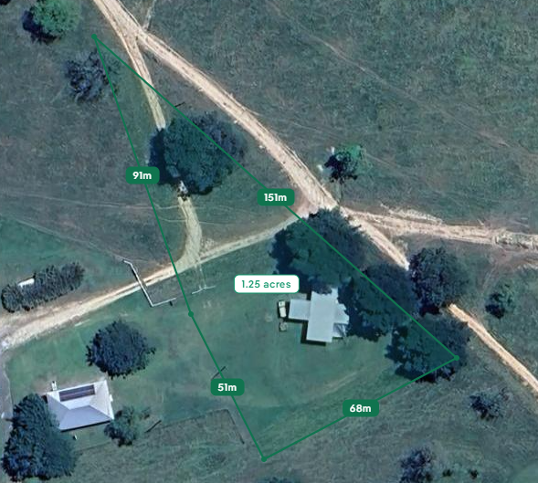

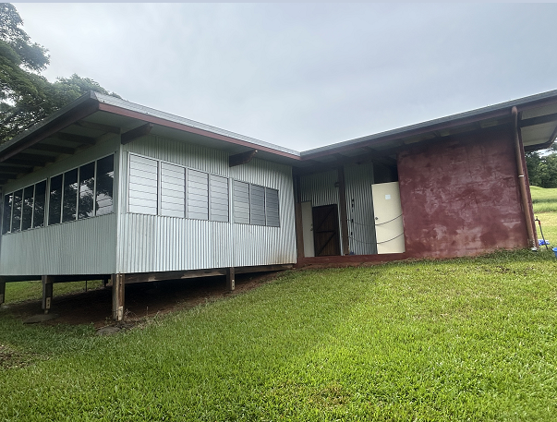
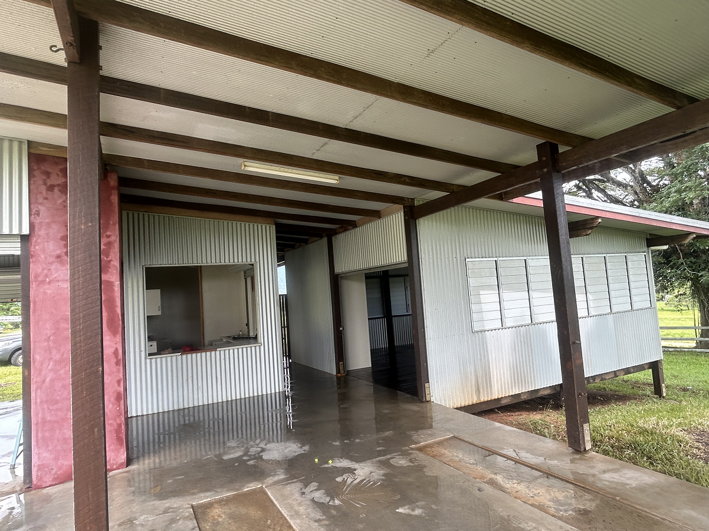

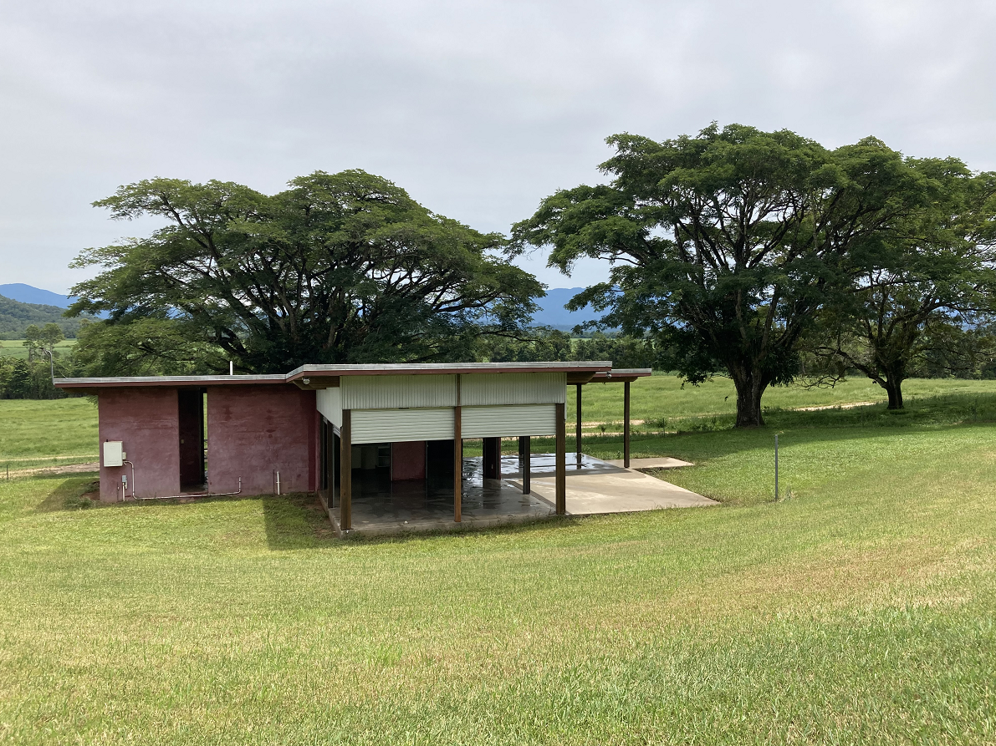
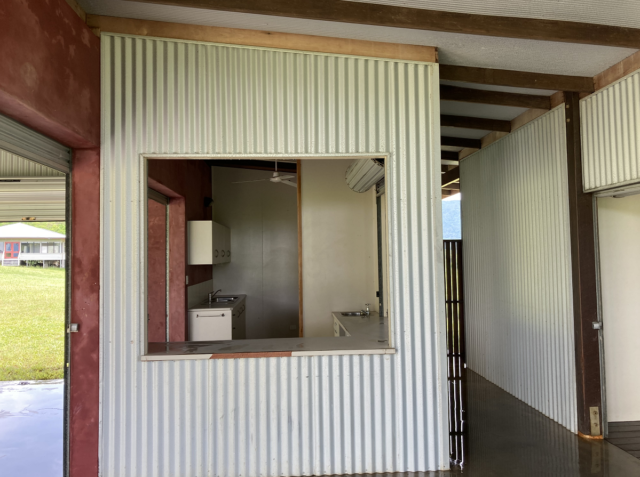
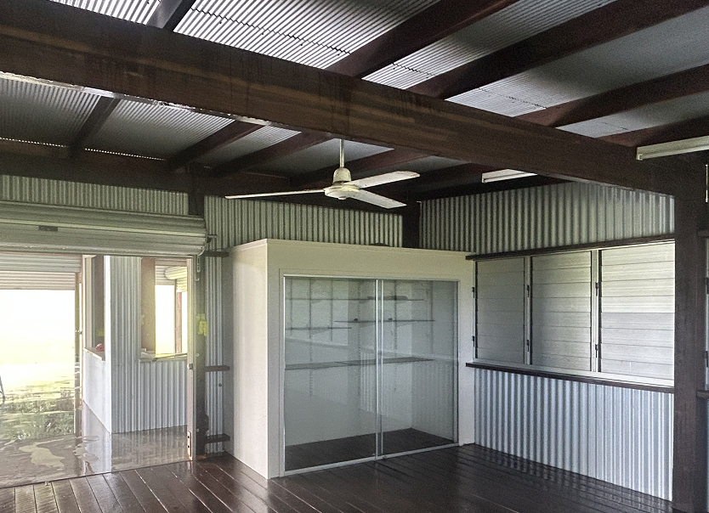

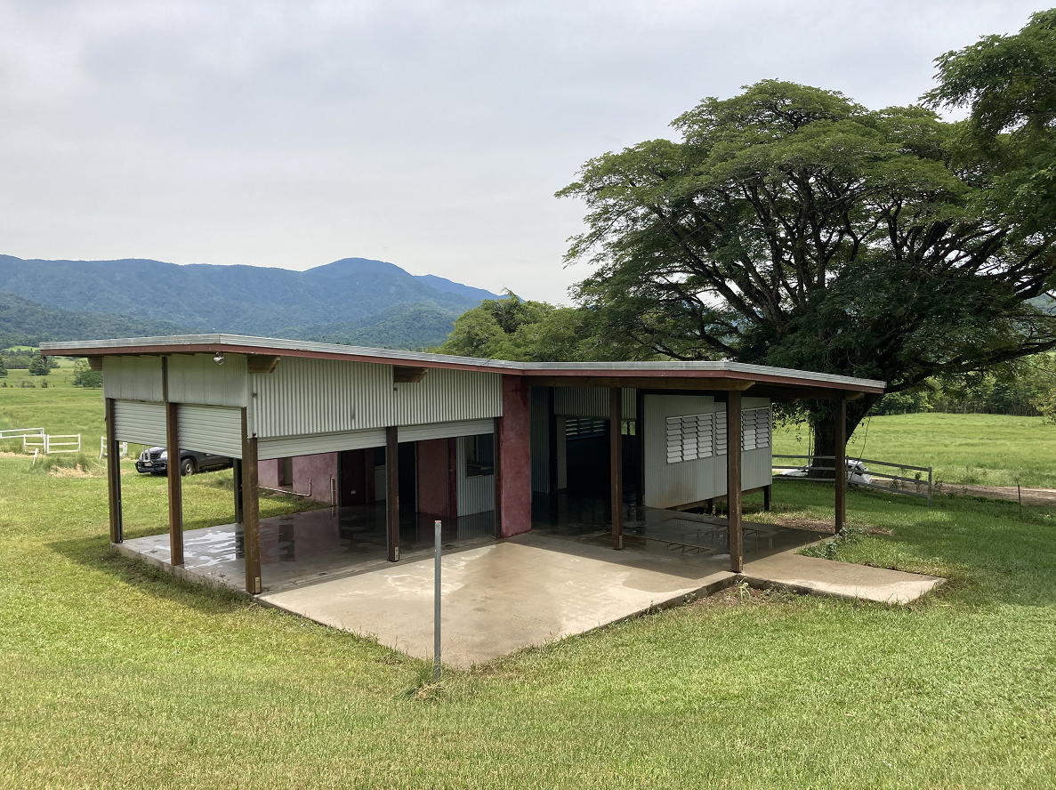
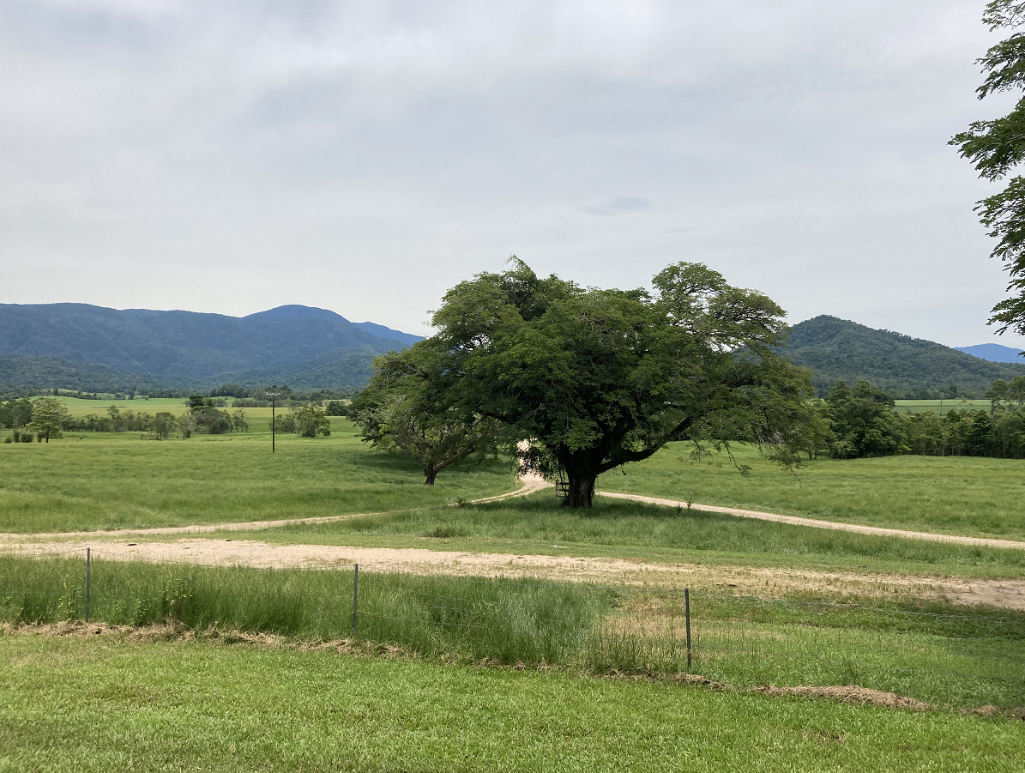

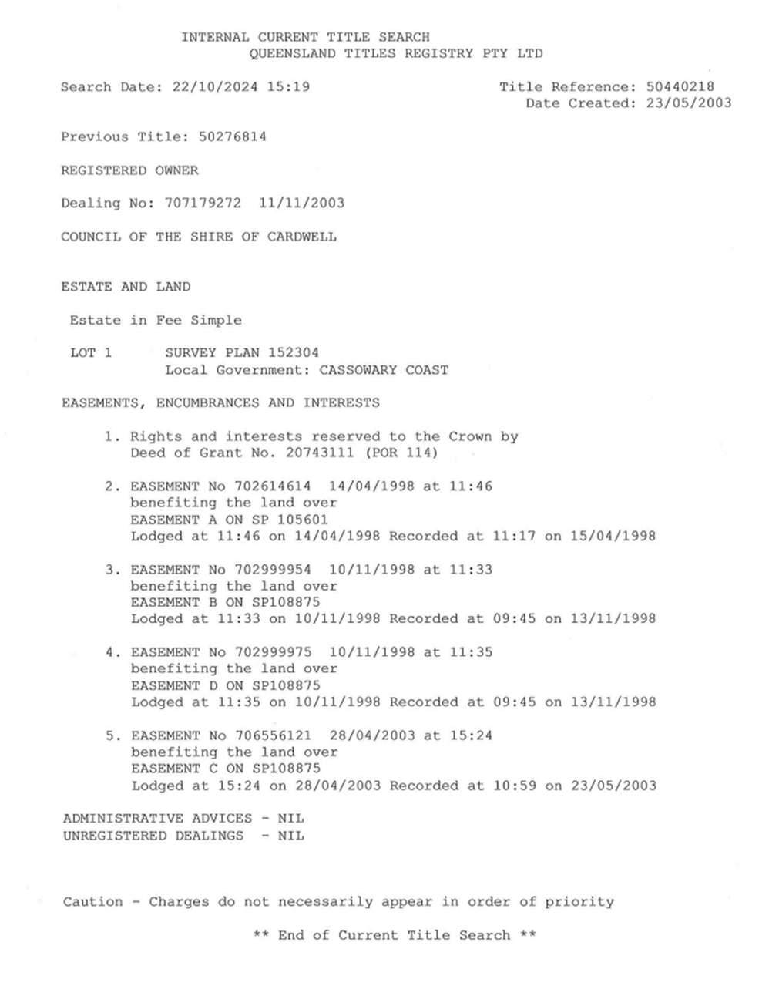
Title search

Improvements

The property is located South of Tully on Munro Plains.
The property comprises a 5,071 square metre triangular shaped internal allotment which is cleared land. The land is in an attractive rural setting, elevated, with view to the north. The land slopes from the south to the north, with the building set on the southern boundary.
Access to the land is via a dirt road which bisects the site towards the northern boundary via registered easements. These easements allow for access only not services.
The property is improved with a circa 2014 theatre style building comprising concrete and timber flooring, a mix of rendered masonry block, corrugated iron and timber external wall and metal roof. The floor plans provided (refer Annexure B) show that the building comprises an entry area, office, stage / workshop area, shop area / bedroom, male / female and disabled amenities. The building footprint is approximately 140m2.
NOTE: The classification of the building does not permit it to be used as a residence. A buyer wishing to occupy the building as a residence would be required to undertake any necessary works and obtain the relevant certificate of classification.
The building has a septic system, however water and electricity services are provided from the neighbouring land and are not protected by any agreement or easements. An agreement / easement would need to be established to maintain the existing services or new service connections would need to be established at the buyer’s cost.
The property and improvements are sold in an “as is” condition. Attached is a building inspection report dated 24 October 2024 (refer Annexure C). Since that date of this report, Cassowary Coast Regional Council has cleaned out and pressure cleaned the building however, Cassowary Coast Regional Council gives no warranty or representation as to the accuracy of this report. Any tenderer should conduct their own inspection and evaluation of the property prior to tendering.

Rates and Charges

Rates : $1428.00 per annum
6 monthly charges comprising: $59.50 Fire Levy
$12.50 Rural Fire Brigade Levy Murray Upper
$642.00 2 x Waste – non-residential A

Contact

Enquiries regarding the purchase of this property may be directed to:

Mark Valente Principal – Property and Leasing:
Mobile: 0457 055 737
Email: Mark.Valente@ccrc.qld.gov.au –

Mandy Larsen Facilities Officer – Property and Leasing
Mobile: 0439 368 079
Email: Mandy.Larsen@ccrc.qld.gov.au r

Tender Submissions are to be emailed to: Purchasing@ccrc.qld.gov.au

Authorisation

This sale of land and property is authorised by Andrew Graffen, Chief Executive Officer, Cassowary Coast Regional Council.

Site inspections

Site inspections are proposed for the following dates and times:
Date: Tuesday, 18 February Time: 10:00am – 12:00pm
Date: Saturday, 22 February Time: 10:00am – 12:00pm

RSVP to Mandy Larsen a minimum of 24 hrs prior to inspection date / time.
Email: Mandy.Larsen@ccrc.qld.gov.au
Mobile: 0439 368 079

